**Craft World**

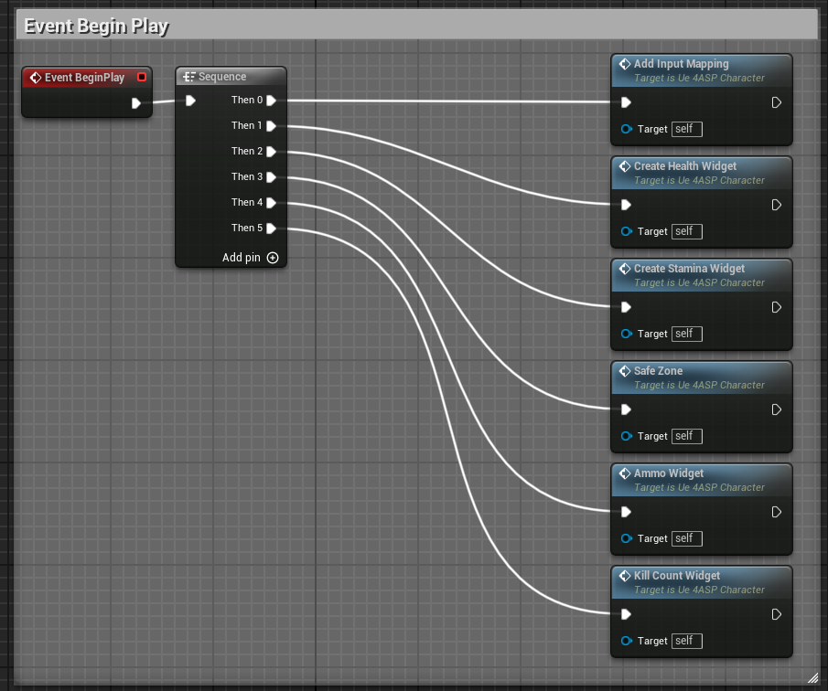

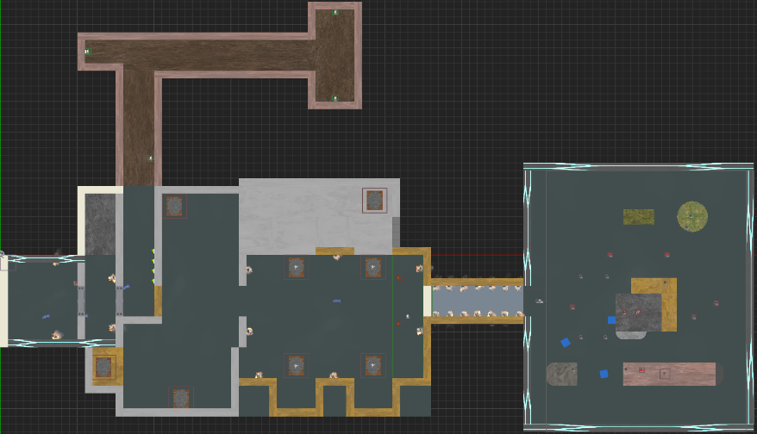

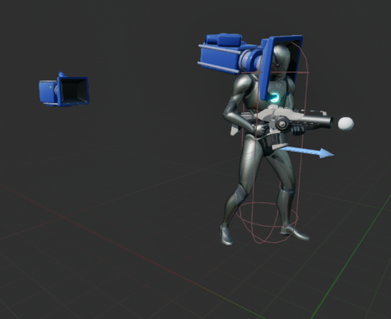

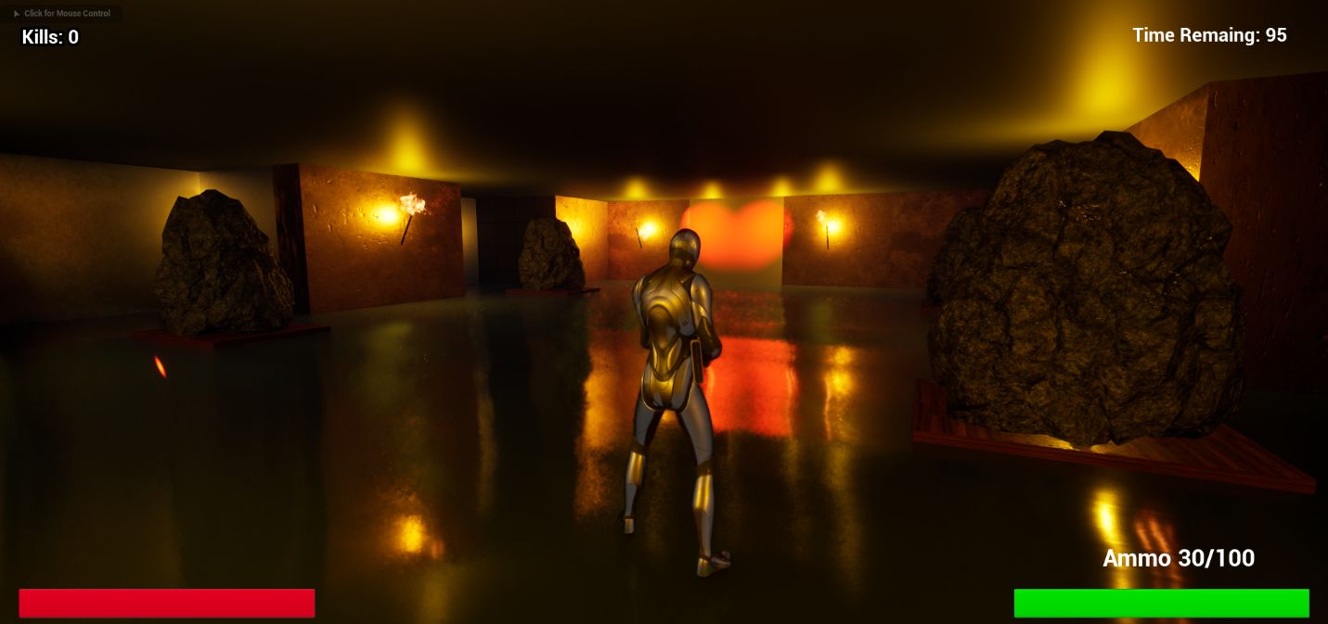

I have planned to create a game with puzzles and shooting. The main reason I chose to add the shooting mechanic to the game is to learn how to create a third-person shooter game with Unreal Engine 5. The base of the game is the player has to solve the puzzle and advance to the next room. The play has a total of 2 minutes to complete the game.

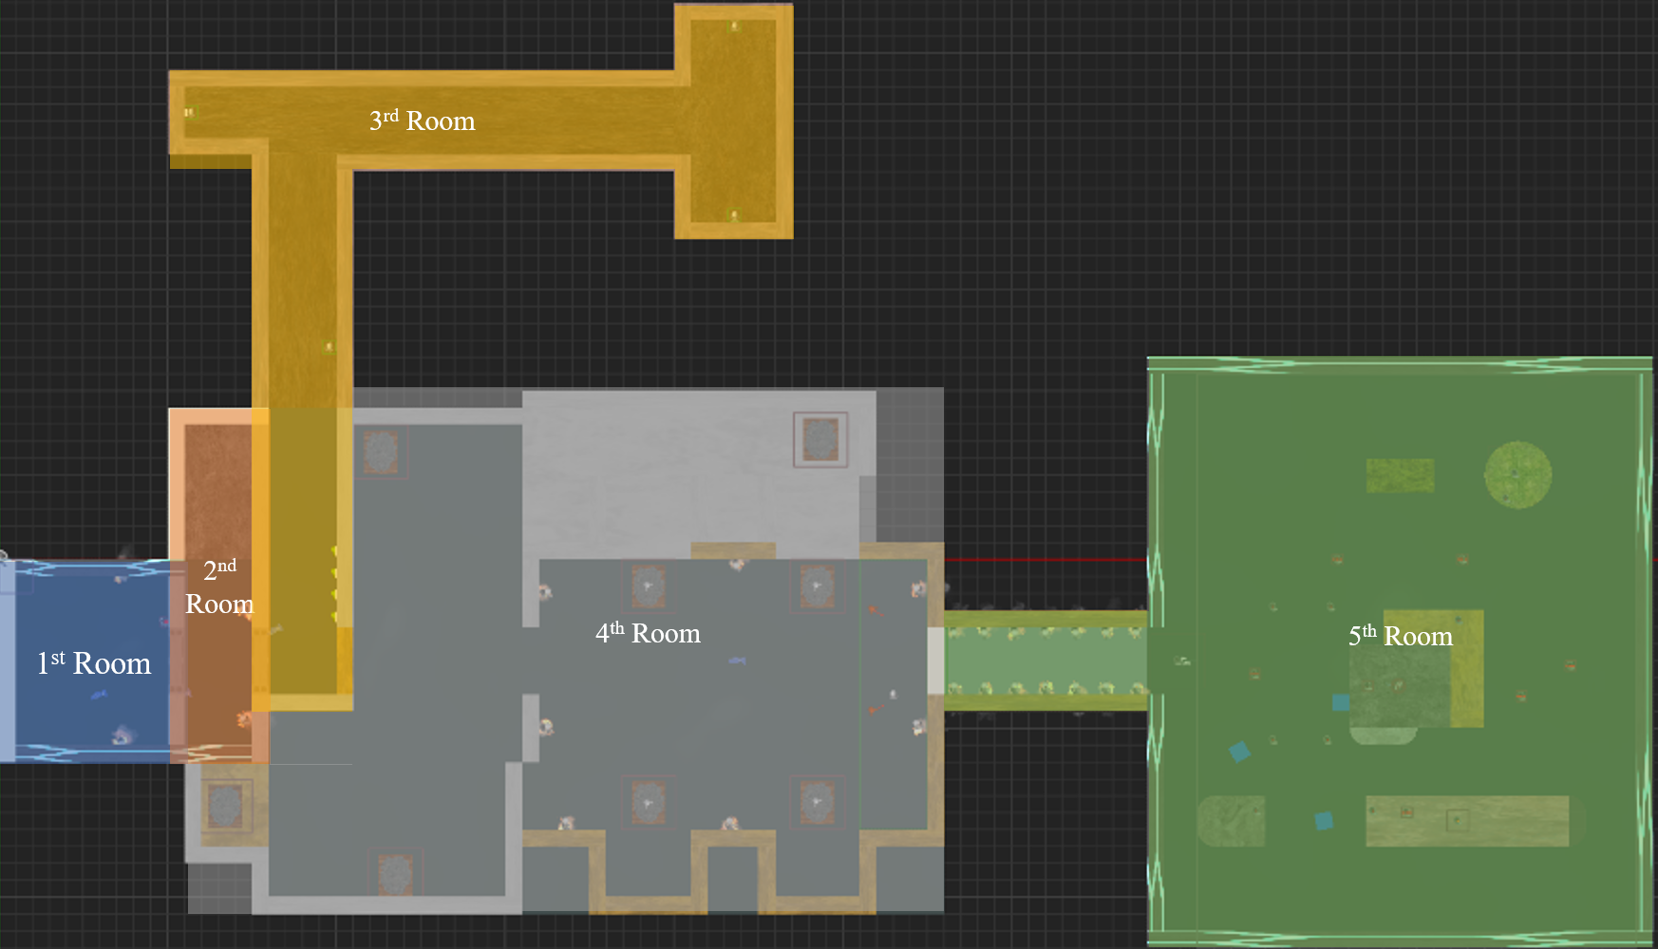

The First room is where the player presses the button, and the door will open.

The Second room is where the player has to find the button to open the door.

The Third room is where the player has to find the button to turn on the light and if all (four) lights are turned on the door will open.

The Fourth room is where the player has the find the rock and collect it and return it to the correct place, if all the rocks are returned to the correct place, the rocks will move to place (Play Sequence) and the door will open.

The Fifth room is where the player has to shoot the enemy until the timer runs out and the game will end.

The Software is very useful for creating games, it has a lot of potential for improvement, It is very user-friendly and easy to use but it has a lot of depth in the software and a lot of information for the user. The project I created was successful. In the Puzzle and logic part, It meets that proposal of what I set out to do but in the animation, texture, shooting, weapon, and combat it needs more time and effort to create a full and smooth gameplay. By adding shooting as part of the game I learned -

how to add effects, muzzle flash and sound effects

how to set up the count system, and logic flow of the game, ammo and reloading,

how to spawn enemies, how to control each custom blueprint, set how many units it will spawn and how many delays at individual spawn points.

how to change the view in the game, third person aiming.

how to damage and heal and set up a widget and display it on the screen for the player to know.

how to create an animation and edit and modify the existing ones, creating an aim offset.

how to create a scoring system, creating kill count.

how to create items when the event end, dead enemies drop ammo.

how to create a countdown timer.

With the puzzle logic, I learned from this paper.

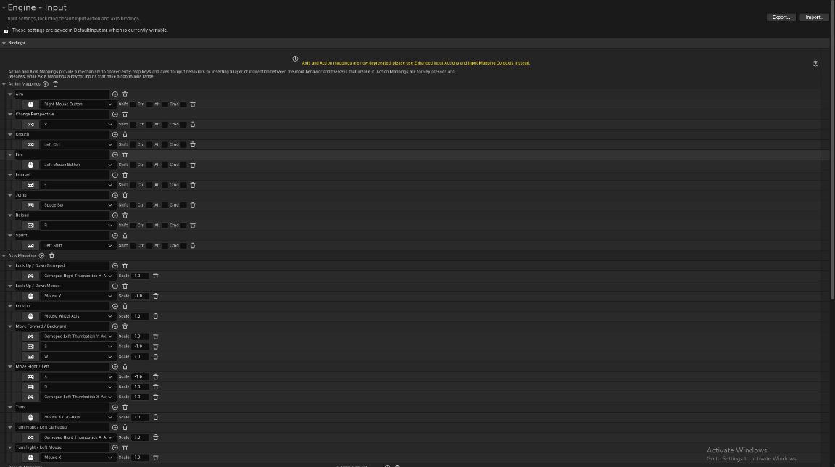The **Mechanics** that I create are

Figure 1 shows all the Action/Axis Mapping/shortcuts that I set up in this project.

Figure 1

~~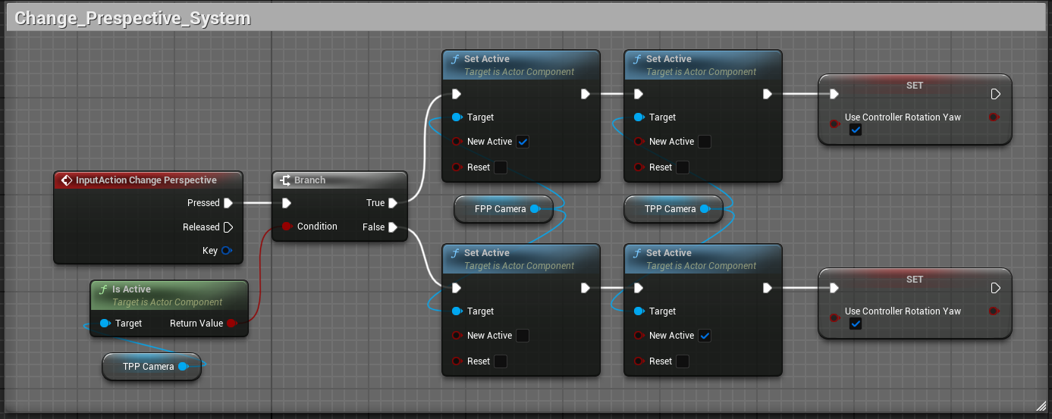~~**Toggle between First Person and Third Person (“V” action key press)**

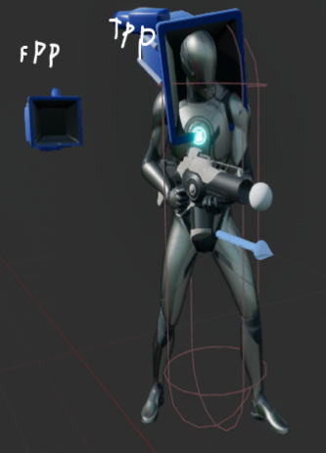As per the figure above, I use the Change Perspective (V key bind) to change between two cameras and set the TPP (Third Person Perspective) as default.

Figure 2

**Puzzle Mechanics: Button, Door , Rock Puzzle, Light Door Puzzle & Arena**

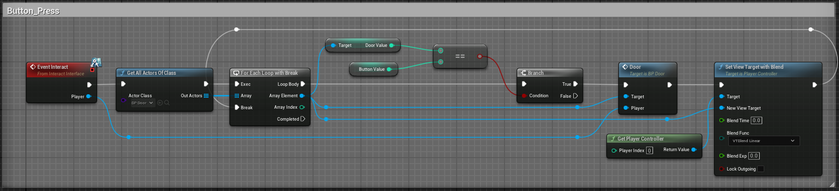

In the BP_Button Figure (Button Blueprint) When the player presses E (Event Intract) it will go through all the buttons & doors on the level, and it will open the door which has the same number as the button and change the camera to the door location.

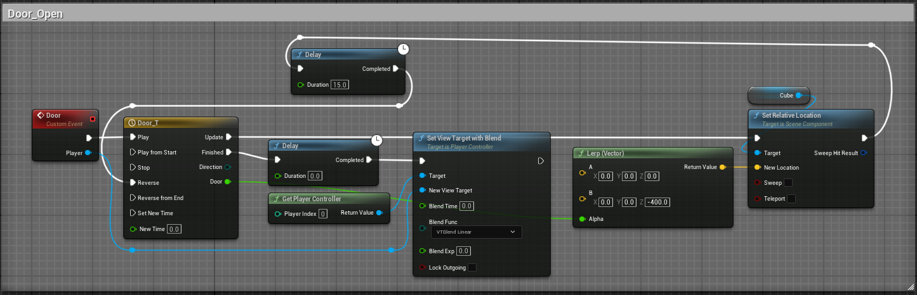

In the BP_Door (Door Blueprint) When the player presses the button it will play the open-door animation.

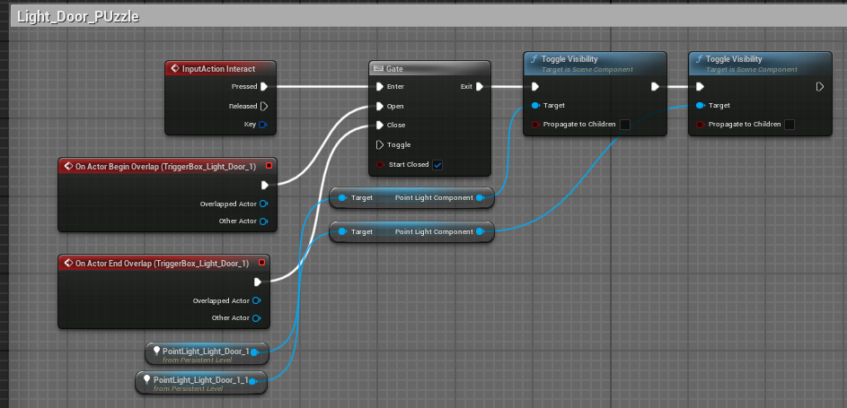

In the Light Door Puzzle When the player overlaps with the trigger box and presses E the light will turn on.

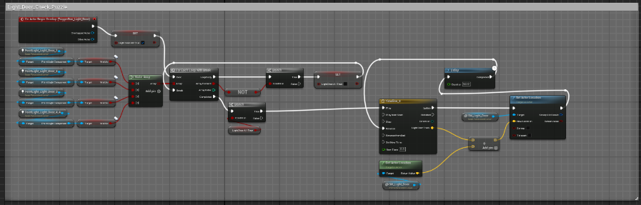Check if all the lights are ON the door will open when you enter the door trigger box.

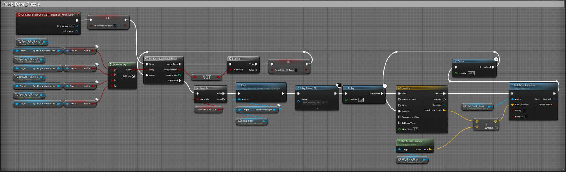

In The Rock_Door_Puzzle Check if all the lights are on with a for each loop, then move the rock (play the sequence about the rock moving) then play sound and open the door.

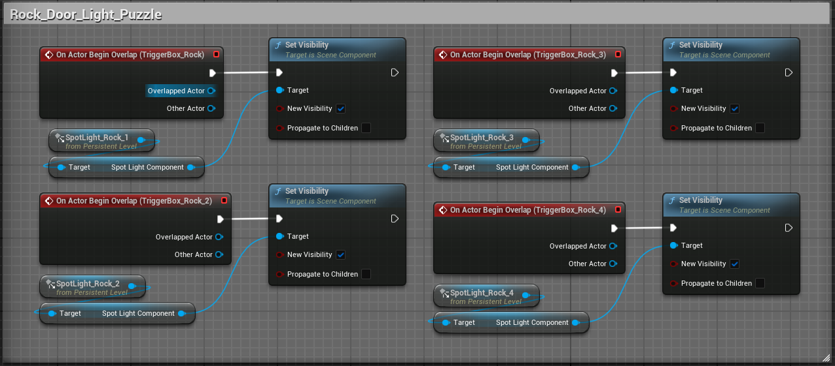

In the Rock_Door_Puzzle when the player places the rock it will turn on the light.

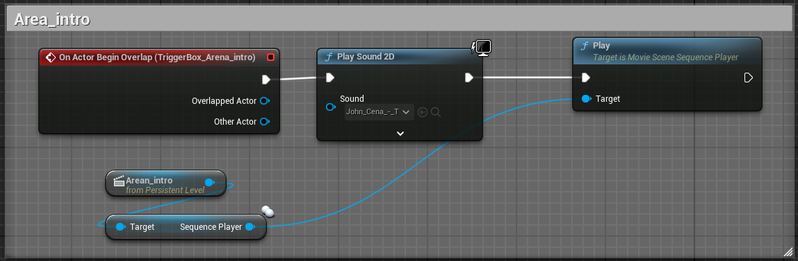

When the player opens the area door it will play the cutscene.

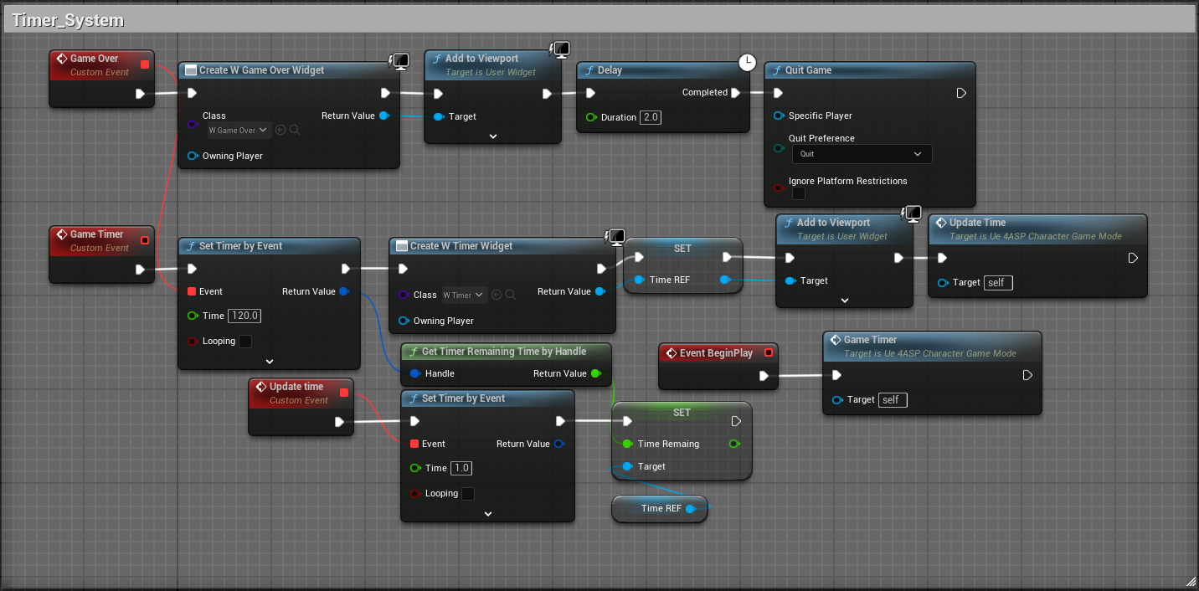

The Timer System is created inside the Game Mode. It creates a timer widget and displays it the viewport You can set the total game time here.

**Player Mechanics: Interact System, Healing, Damage &Death System, Spee & Stamina System, Safe Zone, Firing, Reload, Aim System, Damage System.**

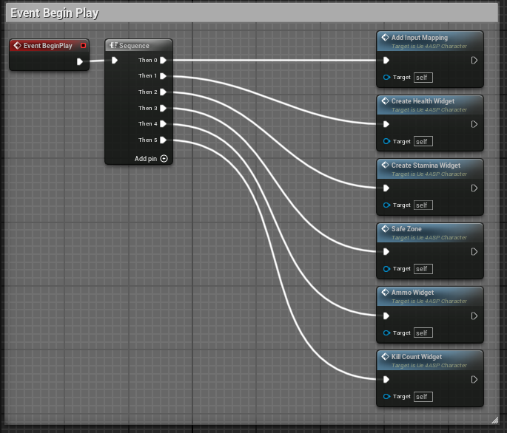When the game starts Health, Stamina, Ammo, Kill Count and Timer will be displayed on the Player Screen.

The player can interact with objects, press buttons, and Collect, The Player has health and stamina. The play can die if the health reaches zero, The Player can Aim, Fire and Reload.

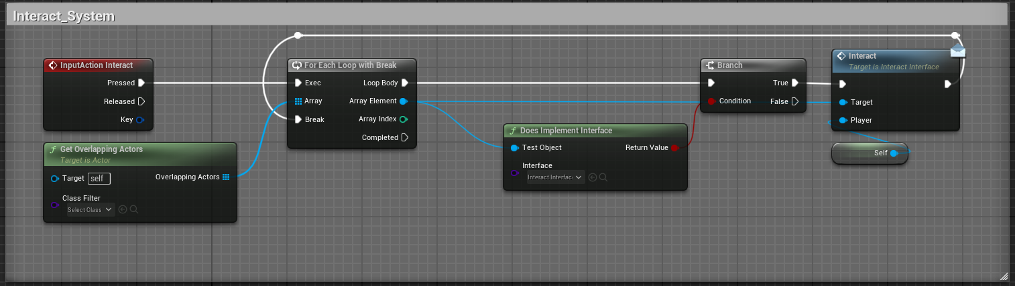

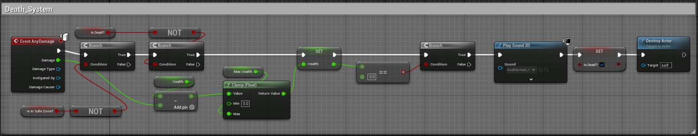Interact System where the player can interact (E key bind) with the object when they overlap. It will go through all which have an interact interface in the level and decide what object os the player will be interacting.

Death System will check if the player is in the safe zone & check if the player is already dead if not player can take damage. If Max health is equal to zero it player will die.

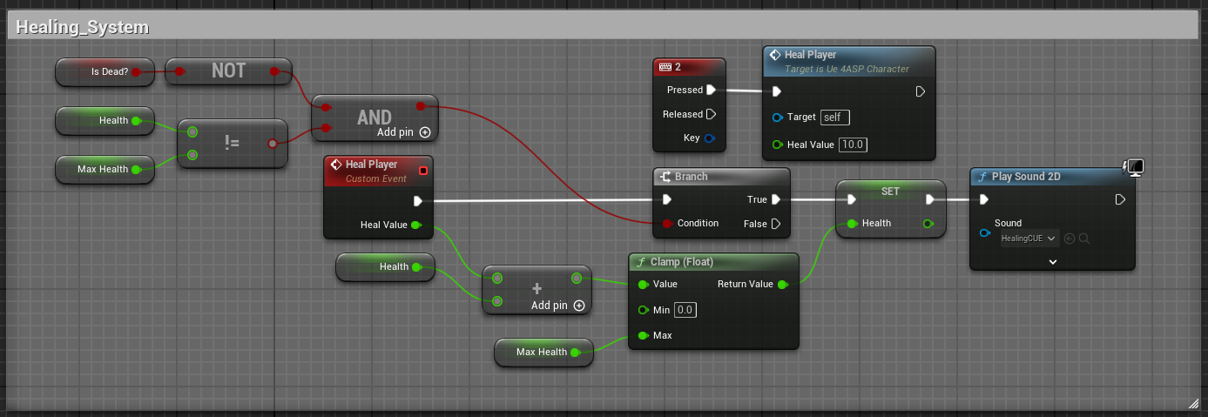

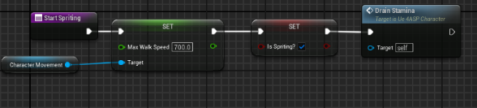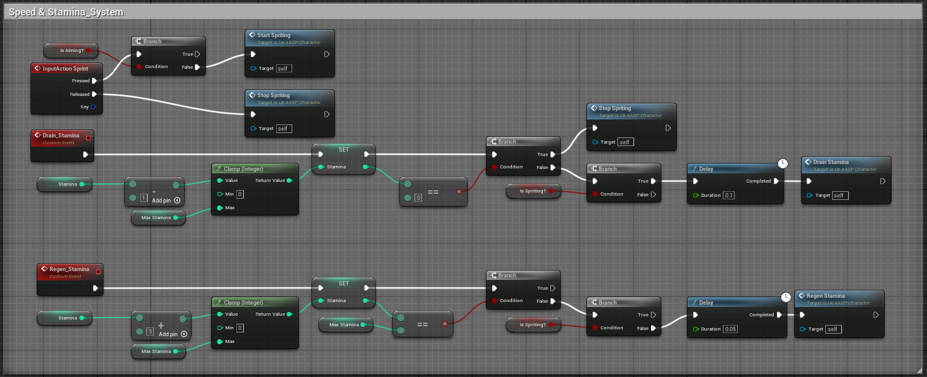The Healing System will check if the player is not dead and if the player is at his max health, if not it will heal the player and play a sound effect. Players can press 2 to heal them self.

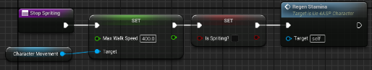

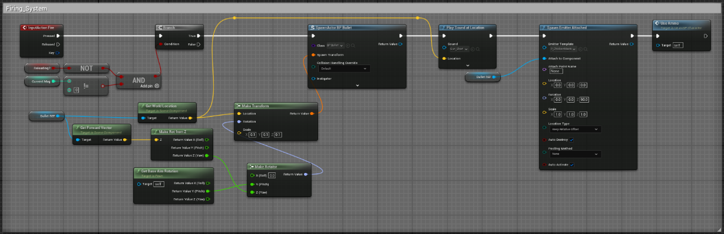Speed & Stamina System will set the player to change max walk speed and when the player runs it will decrease the stamina and it will regen back up when the player stops running.

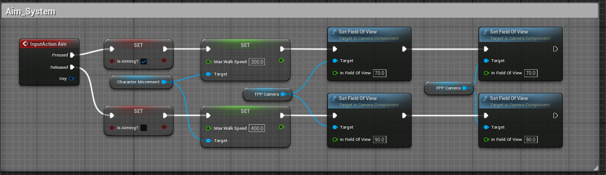When the Player press the left mouse click button it will check if it not reloading or has ammo, then it will create a bullet and set the direction in which bullet will be travelling and play sound.

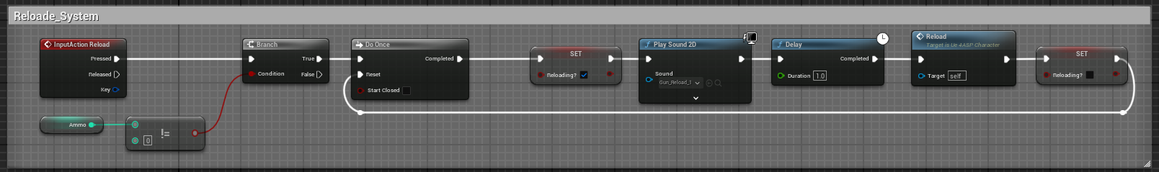Aim System is where the player presses the right mouse click button which will decrease the field of view.

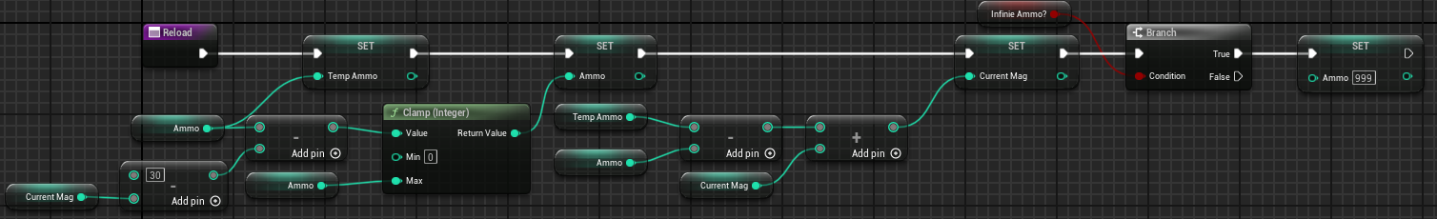

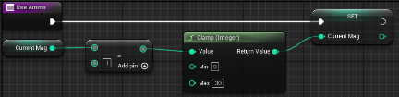

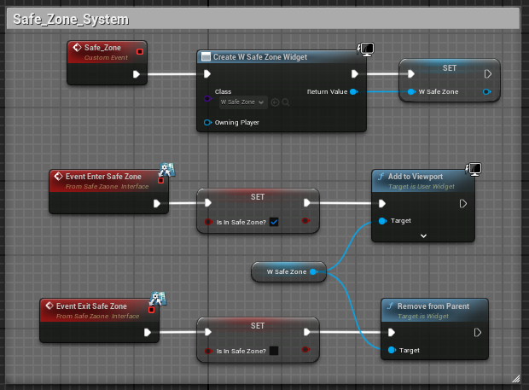Reload System check of the total ammo is equal to zero if not it will play sound and start reloading.In Reload it sets my current mag maximum amount and even time a player fires a bullet decreases one, the developer has option to give player the infinite ammo. When reloaded it will take a temp ammo – ammo then plus with the current mag to get the correct reloading amount.

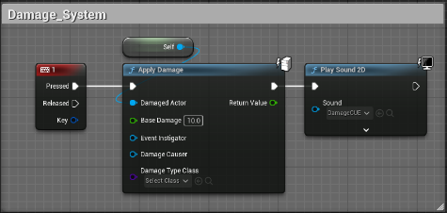Damage System is where players can press 1 to apply damage themself.

In the safe zone, player cannot take damage.

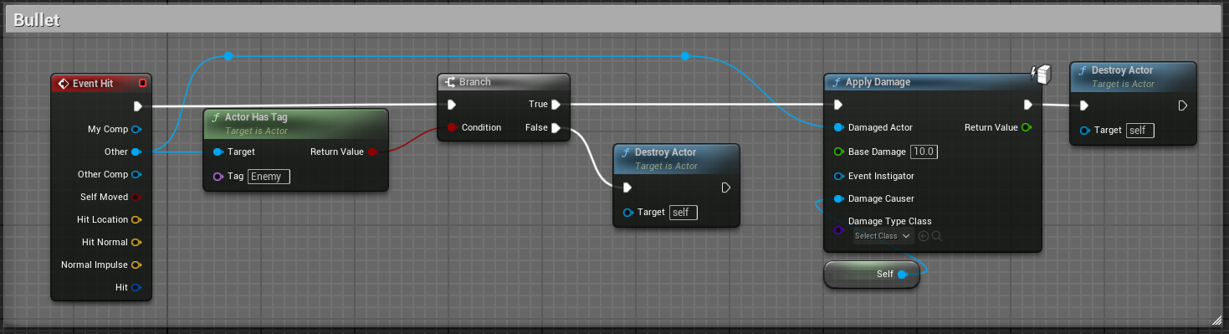

In Bullet blueprint

The bullet will hit if the object has an enemy tag and destroy it self.

**AI Mechanic**: Chase Player, AI Speed System, Damage & Death   
When The game starts AI Enemy will chase the player, The Player can collect the item to increase the AI Enemy's speed and the Player can damage and kill the AI Enemy.

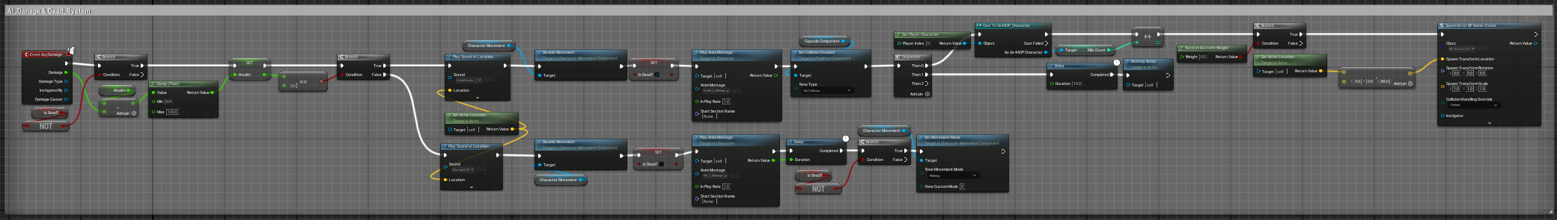

The player can damage the AI Enemy by shooting a bullet if an enemy takes damage it will play the hit animation, play a sound, and stop moving, after the animation end it will chase the player again And if the AI Enemy's health reaches zero they will play the dead animation, play the sound, stop moving and stay dead from 1 min and deleted form the level.

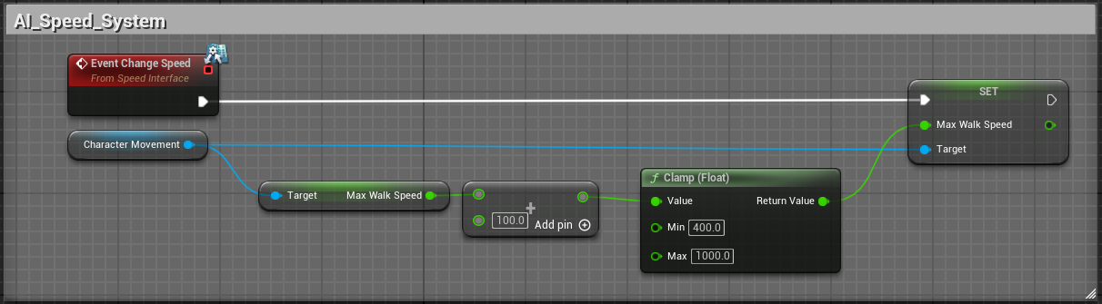

Player can collect the item to increase the AI Enemy walk speed by 100 every time they collect the item.

The player can collect the item to increase the AI Enemy Speed

~~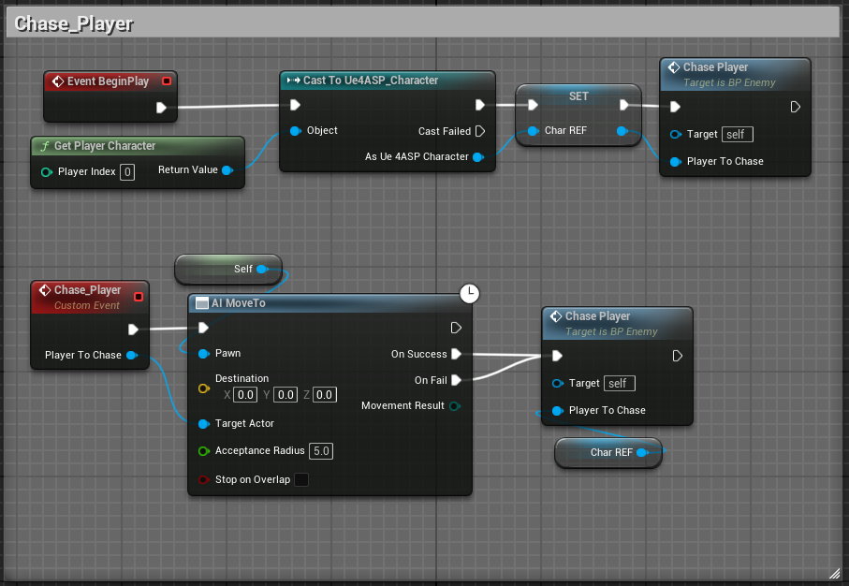~~

When the game starts and when the player enter the area the AI enemy will start moving toward the player.

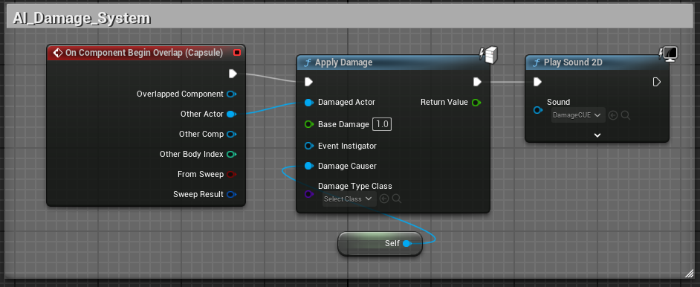

AI Enemy can damage the player when the AI enemy trigger box is overlap with play player will take damage and play the sound effect.

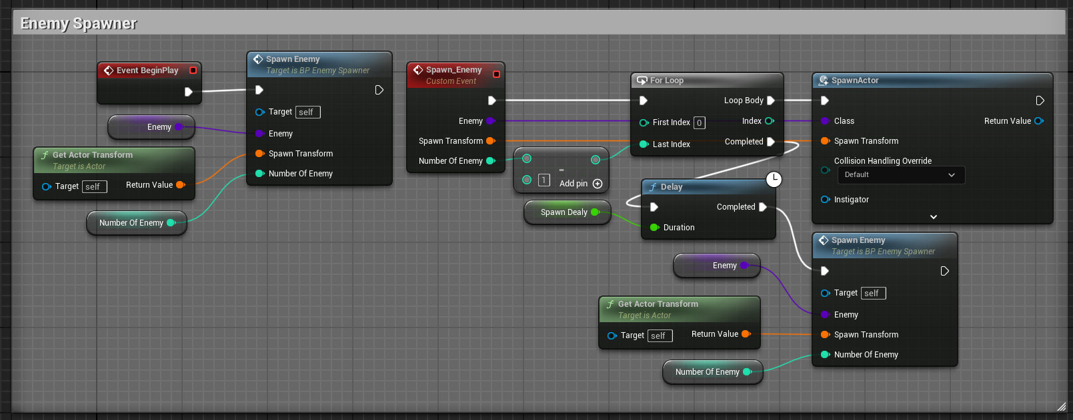

Enemy Spawner will loop through all the spawn point and you can set how many enemy will spawn and what will be the time between spawn to each individual location.

Animation

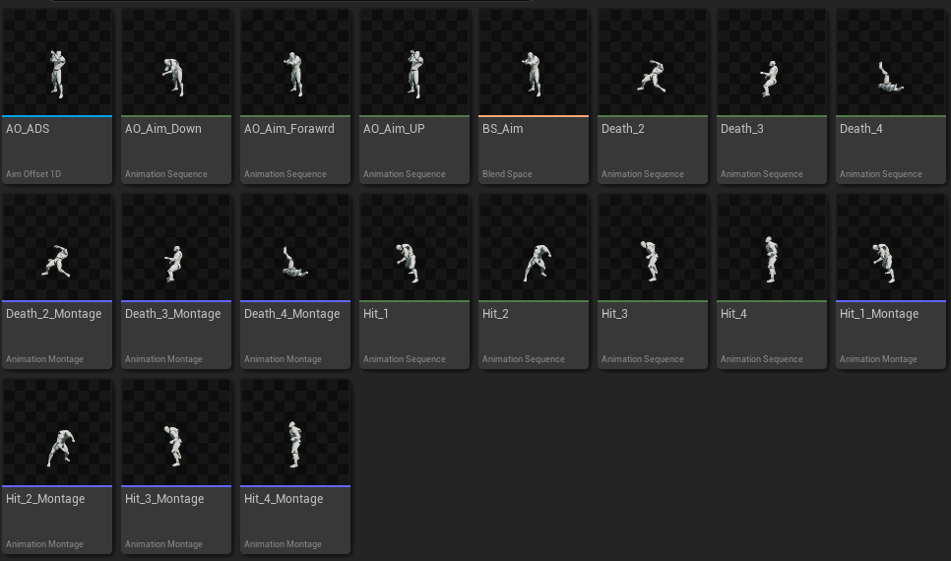

The basic animation is from the “Matt Asland” which he shared from his google drive. All of the item he share are for public and can be use for educational purposes.

[DeathAnimations.zip - Google Drive](https://drive.google.com/file/d/1c99OmE_4iUcy-LPA-JTReLCXuU4q9u-W/view)

Sound

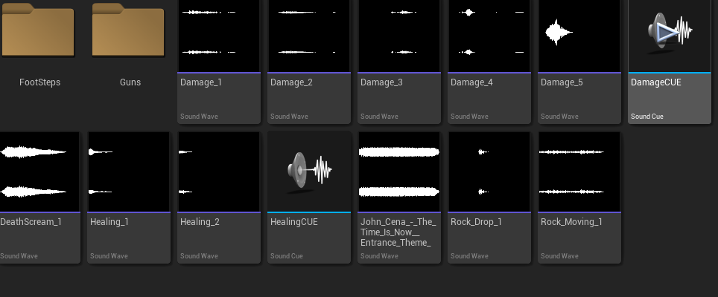

The sound effects I have are from [Freesound](https://freesound.org/) from the file they declare that

“You can copy, modify, distribute and perform the sound, even for commercial purposes, all without the need of asking permission to the author.”

Widget

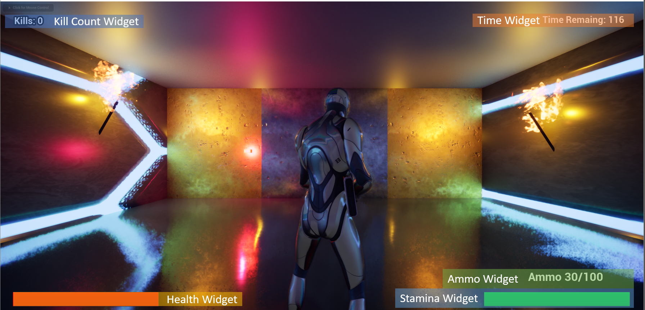

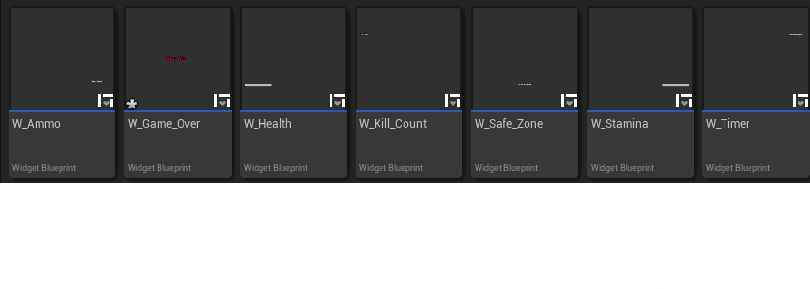

The ammo Widget is for to show the player how much total ammo he has and how many are still left in the mag.

Game Over Widget & Timer Widget is for the time is over it will show the player he has finished the game.

Kill Count Widget allows the player to keep track of how many enemies have been killed by the player.

Health and Stamina Widget is for the player to keep track of the information.

**Time Investment**:

60 hours were dedicated to modelling the game and 8 hours were for writing up the report.

**Achievements and Shortcomings**:

While the primary objectives were met, additional. The Remaining mechanics that need debugging and rework mechanics are smoother and full shooting part of the game.

**Learning Experience:**

Understanding of game mechanics and how they interact to create a cohesive and engaging player experience. The process of designing and implementing features like Player Movement and mechanistic, AI Enemy, and the logic of the game was critical in understanding the delicate balance required in game design. The challenges encountered necessitated a methodical approach to problem-solving and creative and innovative solutions. Creating a game required adaptability and a willingness to learn new techniques and technologies. The development process highlighted the importance of patience and persistence. Creating a game, especially one that is engaging and bug-free, is a time-consuming process that often involves revisiting and revising many aspects of the game multiple times. The skills and knowledge gained through this process are invaluable and will undoubtedly be beneficial in future projects.

**Cost/time analysis**

The estimated cost of this project is $1000.

Development Efficiency:

The time invested versus the project's current stage reflects moderate development efficiency. The more the developer spends time on improving the skill the efficiency will go up.

**Conclusion**

"Craft World" has made commendable progress towards achieving the objectives. However, further development is necessary to resolve current issues and add new features. The project has been both challenging and rewarding, Despite the need for further improvements, the journey of developing "Craft World" third-person puzzle and shooter has been a combination of a series of challenges and achievements.